WEEK: 8
Applying Generative Adversial Networks for image generation and unsupervised tasks.

AIM: To write a python program to apply the Generative Adversial Networks for image generation and unsupervised tasks.

Algorithm:
- Start the program.
- Set random seed for reproducibility.
- Generate 1024 training data points
- Define Networks, Discriminator and Generator.
- Initialize Models, Loss, and Optimizers:
- Training Loop (for 300 epochs):
- Stop the program.

Program:
import torch
from torch import nn
import math
import matplotlib.pyplot as plt

torch.manual_seed(111)

train_data_length = 1024
train_data = torch.zeros((train_data_length, 2))
train_data[:, 0] = 2 * math.pi * torch.rand(train_data_length)
train_data[:, 1] = torch.sin(train_data[:, 0])
train_labels = torch.zeros(train_data_length)
train_set = [
(train_data[i], train_labels[i]) for i in range(train_data_length)
]

# Plot training data
plt.plot(train_data[:, 0], train_data[:, 1], ".")
plt.show()

# Create a PyTorch data loader
batch_size = 32
train_loader = torch.utils.data.DataLoader(
train_set, batch_size=batch_size, shuffle=True
)

# Implementing the Discriminator
class Discriminator(nn.Module):
def __init__(self):
super().__init__()
self.model = nn.Sequential(
nn.Linear(2, 256),
nn.ReLU(),
nn.Dropout(0.3),
nn.Linear(256, 128),
nn.ReLU(),
nn.Dropout(0.3),
nn.Linear(128, 64),
nn.ReLU(),
nn.Dropout(0.3),
nn.Linear(64, 1),
nn.Sigmoid(),
)

def forward(self, x):
output = self.model(x)
return output

# Instantiate a Discriminator object
discriminator = Discriminator()

# Implementing the Generator
class Generator(nn.Module):
def __init__(self):
super().__init__()
self.model = nn.Sequential(
nn.Linear(2, 16),
nn.ReLU(),
nn.Linear(16, 32),
nn.ReLU(),
nn.Linear(32, 2),
)

def forward(self, x):
output = self.model(x)
return output

generator = Generator()

# Training the models
lr = 0.001
num_epochs = 300
loss_function = nn.BCELoss()

# Create the optimizers using Adam optimizer
optimizer_discriminator = torch.optim.Adam(discriminator.parameters(), lr=lr)
optimizer_generator = torch.optim.Adam(generator.parameters(), lr=lr)

# Implement a training loop in which training samples are fed to the models, and their weights are updated to minimize the loss function:
for epoch in range(num_epochs):
for n, (real_samples, _) in enumerate(train_loader):
# Data for training the discriminator
real_samples_labels = torch.ones((batch_size, 1))
latent_space_samples = torch.randn((batch_size, 2))
generated_samples = generator(latent_space_samples)
generated_samples_labels = torch.zeros((batch_size, 1))
all_samples = torch.cat((real_samples, generated_samples))
all_samples_labels = torch.cat(
(real_samples_labels, generated_samples_labels)
)

# Training the discriminator
discriminator.zero_grad()
output_discriminator = discriminator(all_samples)
loss_discriminator = loss_function(
output_discriminator, all_samples_labels)
loss_discriminator.backward()
optimizer_discriminator.step()
# Data for training the generator
latent_space_samples = torch.randn((batch_size, 2))
# Training the generator
generator.zero_grad()
generated_samples = generator(latent_space_samples)
output_discriminator_generated = discriminator(generated_samples)
loss_generator = loss_function(
output_discriminator_generated, real_samples_labels
)
loss_generator.backward()
optimizer_generator.step()

# Show loss
if epoch % 10 == 0 and n == batch_size - 1:
print(f"Epoch: {epoch} Loss D.: {loss_discriminator}")
print(f"Epoch: {epoch} Loss G.: {loss_generator}")
# Checking the samples generated by the GAN
latent_space_samples = torch.randn(100, 2)
generated_samples = generator(latent_space_samples)
generated_samples = generated_samples.detach()
plt.plot(generated_samples[:, 0], generated_samples[:, 1], ".")
plt.show()

Output:
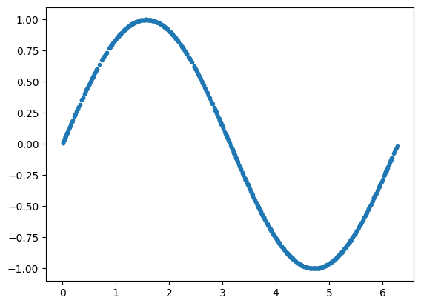

Epoch: 0 Loss D.: 0.19106777012348175
Epoch: 0 Loss G.: 1.888679027557373
Epoch: 10 Loss D.: 0.6593940854072571
Epoch: 10 Loss G.: 0.9345511198043823
Epoch: 20 Loss D.: 0.6652078628540039
Epoch: 20 Loss G.: 0.9237955808639526
Epoch: 30 Loss D.: 0.641313910484314
Epoch: 30 Loss G.: 1.2015199661254883
Epoch: 40 Loss D.: 0.641319751739502
Epoch: 40 Loss G.: 0.888908863067627
Epoch: 50 Loss D.: 0.6150982975959778
Epoch: 50 Loss G.: 0.7767004370689392
Epoch: 60 Loss D.: 0.6709685325622559
Epoch: 60 Loss G.: 0.960426390171051
Epoch: 70 Loss D.: 0.7082744240760803
Epoch: 70 Loss G.: 0.6963481903076172
Epoch: 80 Loss D.: 0.6969344019889832
Epoch: 80 Loss G.: 0.7154377102851868
Epoch: 90 Loss D.: 0.6964524984359741
Epoch: 90 Loss G.: 0.6930248737335205
Epoch: 100 Loss D.: 0.6739951968193054
Epoch: 100 Loss G.: 0.6828322410583496
Epoch: 110 Loss D.: 0.6988975405693054
Epoch: 110 Loss G.: 0.6890343427658081
Epoch: 120 Loss D.: 0.6542428731918335
Epoch: 120 Loss G.: 0.7526243925094604
Epoch: 130 Loss D.: 0.6785508394241333
Epoch: 130 Loss G.: 0.7214392423629761
Epoch: 140 Loss D.: 0.6713313460350037
Epoch: 140 Loss G.: 0.9905208945274353
Epoch: 150 Loss D.: 0.6244789361953735
Epoch: 150 Loss G.: 0.8868338465690613
Epoch: 160 Loss D.: 0.6433807015419006
Epoch: 160 Loss G.: 0.877221405506134
Epoch: 170 Loss D.: 0.6085188388824463
Epoch: 170 Loss G.: 1.2199158668518066
Epoch: 180 Loss D.: 0.627951979637146
Epoch: 180 Loss G.: 0.7479653358459473
Epoch: 190 Loss D.: 0.7258119583129883
Epoch: 190 Loss G.: 0.7802707552909851
Epoch: 200 Loss D.: 0.6872613430023193
Epoch: 200 Loss G.: 0.8110033273696899
Epoch: 210 Loss D.: 0.6713621616363525
Epoch: 210 Loss G.: 1.0470393896102905
Epoch: 220 Loss D.: 0.7211101055145264
Epoch: 220 Loss G.: 0.8180935382843018
Epoch: 230 Loss D.: 0.7034702301025391
Epoch: 230 Loss G.: 0.7519649863243103
Epoch: 240 Loss D.: 0.6815218925476074
Epoch: 240 Loss G.: 0.8854950666427612
Epoch: 250 Loss D.: 0.6458157300949097
Epoch: 250 Loss G.: 0.87900710105896
Epoch: 260 Loss D.: 0.6823645830154419
Epoch: 260 Loss G.: 0.7525910139083862
Epoch: 270 Loss D.: 0.622257649898529
Epoch: 270 Loss G.: 0.7235262393951416
Epoch: 280 Loss D.: 0.7472313642501831
Epoch: 280 Loss G.: 0.7774851322174072
Epoch: 290 Loss D.: 0.6672558784484863
Epoch: 290 Loss G.: 0.7349084615707397
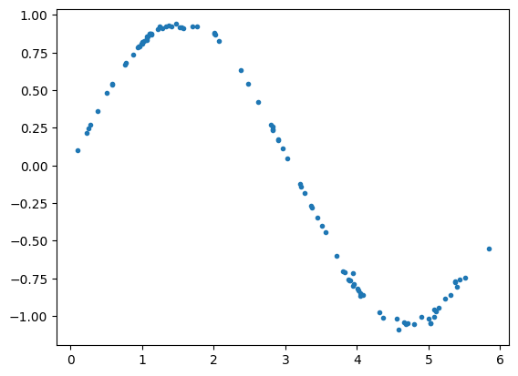

Result:
Thus, python program to apply the Generative Adversial Networks for image generation and unsupervised tasks are executed successfully.

